**Project Design Phase-II**

**Data Flow Diagram & User Stories**

| Date | 31 june 2025 |
| --- | --- |
| Team ID | LTVIP2025TMID28960 |
| Project Name | Automated Car Catalog System For Enhanced Showroom Management |
| Maximum Marks | 4 Marks |

**Data Flow Diagrams:**

The Data Flow Diagram (DFD) for the Automated Car Catalog System illustrates the flow of data between key components and users involved in managing car requests and inventory in a showroom environment. The process begins with a Customer initiating a request to explore or book a car, which generates request data that flows into the Automated Car Catalog System. This central system processes user inputs, filters car options based on category or availability, and presents matching results.

Once a selection is made, the system sends the booking or inquiry to the Showroom Manager for approval or further action. After approval, the Inventory system is updated with the latest availability status or booking details. The system ensures real-time synchronization between inventory and catalog, providing up-to-date car details such as model, price, and stock levels.

This DFD highlights clear communication between the external entities (Customer and Manager), internal data stores (Request Data and Inventory), and the main processing system (Car Catalog). It ensures efficient car management, quick customer service, and smooth coordination between catalog and inventory updates, enhancing overall showroom performance.

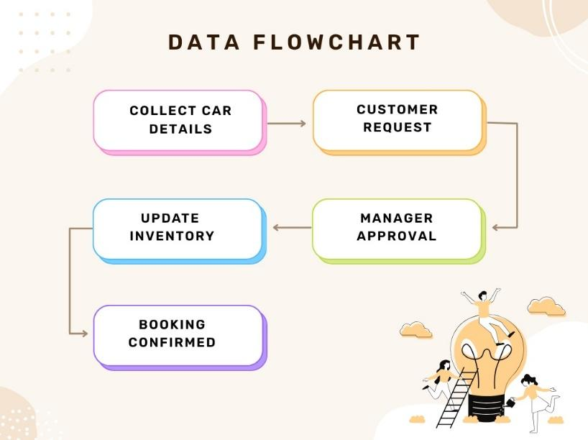

**AUTOMATED CAR CATALOG SYSTEM**

**User Stories**

| **User Type** | **Functional Requirement (Epic)** | **User Story Number** | **User Story / Task** | **Acceptance criteria** | **Priority** | **Release** |
| --- | --- | --- | --- | --- | --- | --- |
| Customer | Car Search & Request | USN-1 | As a customer, I can search and request a car from the catalog | The request is captured and shown to the showroom manager. | High | Sprint-1 |
| Customer | View Request Status | USN-2 | As a customer, I can view the status of my car request. | The system displays: Pending/ approved/rejected. | Medium | Sprint-2 |
| Manager | Approve/Reject car Requests | USN-3 | |  | | --- |  | As a manager, I can approve or reject car booking requests. | | --- | | Approval or rejection updates the status and notifies the user. | High | Sprint-1 |
| Inventory staff | Update car Inventory | USN-4 | |  | | --- |  | As an inventory staff , I can update the stock after a approved. | | --- | | Car stock reduces based on booking status | High | Sprint-2 |
| System | Notifications | USN-5 | As a system, I can send notifications to users and managers. | Notification sent via email or system alert. | Medium | Sprint-2 |
| Admin | Audit & Reports | USN-6 | As an admin, I can generate reports of car bookings, approvals, and stock. | Reports show logs of all actions by user and system. | Low | Sprint-3 |
| Admin | Manage Users | USN-7 | As an admin, I can add or remove customers and managers from the platform. | Changes in access reflect in the system accurately. | Medium | Sprint-3 |
| Customer | Cancel Car Request | USN-8 | As a customer , I can cancel my car booking request before it’s approved. | Request status is set to "cancelled" and is not editable anymore. | Low | Sprint-2 |